**Project Details**

|  |  |
| --- | --- |
| Project number | *Project 1* |
| Project title | *Mega Store* |
| Corresponding TA\LA | *1* |
| Deliverable | *Phase 1* |

**Team Details**

**Team 8**

|  |  |  |
| --- | --- | --- |
| **Student ID** | **Student name** | **Lab Group** |
| 20200403 | Loay Mohamed Hussien | S3-S4 |
| 20200490 | Mahmoud Ahmed Abdo | S1-S2 |
| 20200687 | Ibrahim Rashid Ibrahim | S1-S2 |
| 20200479 | Mohammed Nasser Abdel-Samea | S1-S2 |
| 20200125 | Ganna Allah Khaled Fouad | S3-S4 |
| 20201185 | Nadeen Medhat Assem Abdel-Latif | S3-S4 |
| 20200143 | Habiba Adel Lotfy ELbatrawy | S3-S4 |

1. Use cases model:
   1. **Using Event Decomposition technique:**

Table / Types of Events

* + 1. Types of Events

|  |  |
| --- | --- |
| Event | Type  (External/State/temporal) |
| Getting points for buying products. | External |
| Giving points for buying special bags. | State |
| Add/update products information. | State |
| Remove products information. | State |
| Return product (refund). | Temporal |
| Add/update offers. | Temporal |
| Make payment. | External |
| Make a financial report. | State |
| Manager purchase history | state |
| Customer can buy through off-site service. | External |
| Customer can buy through on-site service. | External |
| Manager provides different categories. | State |
| Add products to different categories. | State |
| Customer searches for products. | External |
| Customer add products to cart | External |

* + 1. Formalize events with use cases

Table 2- Formalizing Events to use cases

|  |  |  |
| --- | --- | --- |
| Event | Type  (External/State/temporal) | Use case |
| Getting points for buying products. | External | Gain points |
| Giving points for buying special bags. | State | Provide special bags |
| Add/update products information. | State | Add products information |
| Remove products information. | State | Remove products |
| Return product (refund). | Temporal | Return product |
| Add/update offers. | Temporal | Make offers |
| Make payment. | External | Checkout |
| Make a financial report. | State | View search history |
| Customer can buy through off-site service. | External | Buy product |
| Customer can buy through on-site service. | External | Buy product |
| Manager provides different categories. | State | Provide different categories |
| Add products to different categories. | State | Add products |
| Customer searches for products. | External | Search for products |
| Manager purchase history | state | Purchase history |

* + 1. Use case Descriptions:

Table 3 - Use cases descriptions

|  |  |  |
| --- | --- | --- |
| Use case name | Actor | Description |
| Add Products | Manager | The manager adds new items in the system. |
| Add products information | Manager | The manager adds or updates the products information. |
| Provide services | Manager | The manager provides services to the customer. |
| Make offers | Manager | The manager makes offers for products in special events like local events or global events. |
| Remove products | Manager | In this case the manager deletes the products from the system. |
| Has warehouses | Manager | The manager owns warehouses and rents others in some countries. |
| Deal with suppliers | Manager | In this case the manager deals with suppliers to provide different products to warehouses. |
| Provide different categories | Manager | In this case the manager adds variety of categories in his stores. |
| Provide special bags | Manager | The manager provides this option to raise the awareness about the environment. |
| Enhance services | Manager | The system has some features in order to enhance the services. |
| Make a financial report | Manager | The manager can see/update the financial status of the stores. |
| Purchase history | Manager | Manager views this feature to enhance services. |
| Operate different stores | Manager | The manager operates a chain of hypermarkets, groceries stores, and convenience stores. |
| Return products (check return policy) | Customer | In this case the customer can return products if they are returnable. |
| Gain points | Customer | Customer gains points through buying products and using the special bags. |
| Buy special bags | Customer | The customer can buy special bags to increase his points and preserve the environment. |
| Buy products | Customer | The customer can buy products, get offers and use points for discounts if he has any. |
| Visit physical location | On-site customer | On-site customer can visit the nearest store from his house to buy products. |
| Achieved through website | Off-site customer | The customer can reach the mega store through website to buy or to know new offers and prices of products. |
| Achieved through mobile app | Off-site customer | The customer can reach the mega store through mobile application to buy or to know new offers and prices of products. |
| Search for products | Off-site customer | In this case the customer search  For products by its category to buy from the store. |
| Add products to cart | Off-site customer | Customer can add product to his cart. |
| Checkout | Payment system | The payment system makes payment process and display receipt. |

1.1.4. Matrix that maps all domain classes to the set of use cases

|  |  |  |  |  |
| --- | --- | --- | --- | --- |
| Use case  **Vs.**  Domain Class | Domain Class 1 | Domain Class 2 | Domain Class 3 | Domain Class 4 |
| Add Products | Manager | Product | - | - |
| Add products information | Manager | Product | - | - |
| Provide services | Manager | Offers | - | - |
| Make offers | Manager | Offers | - | - |
| Remove products | Manager | Product | - | - |
| Has warehouses | Manager | - | - | - |
| Deal with suppliers | Manager | Supplier | Product | - |
| Provide different categories | Manager | Category | - | - |
| Provide special bags | Manager | specialBags | - | - |
| Enhance services | Manager | History | - | - |
| Make a financial report | Manager | Report | - | - |
| Operate different stores | Manager | Stores | - | - |
| Return products | Customer | Product | Payment | - |
| Gain points | Customer | Offers | Payment | specialBags |
| Buy special bags | Customer | specialBags | Payment | - |
| Buy products | Customer | Product | Payment | Stores |
| Visit physical location | Customer | Store | - | - |
| Achieved through website | Customer | Store | - | - |
| Achieved through mobile app- | Customer | Store | - | - |
| Search for products | Customer | Product | - | - |
| Checkout | Customer | Payment | Offers | - |

1.1.5. Use case Diagram:

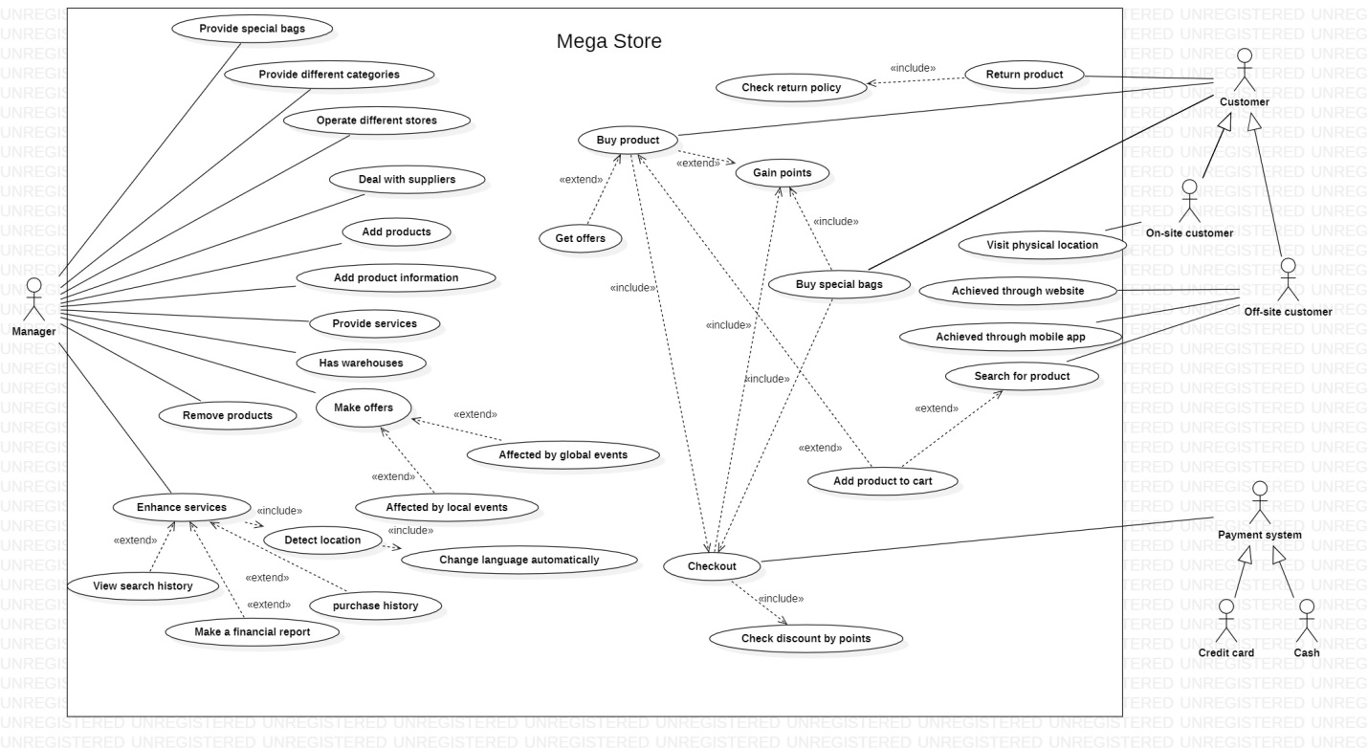

**Note that:**

You must use a tool, no hand-made model will be accepted.

Please state/mention which **tool** you have used at the end of the document.

[Using any CASE tool]

ArgUML

StarUML

Signavio {}

Bizagi modelling tool

…

**[Hint: Review Chapters 3 – 4: Use cases & domain classes]**